To set up:
- Log into https://sas.elluminate.com/site/external/login/user with your username and password
- Click Utilities then Meetings
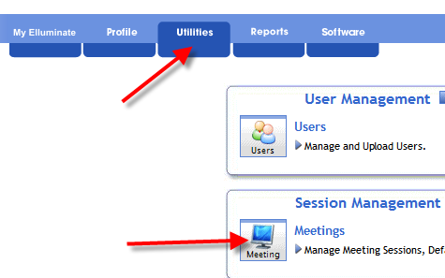
- Click Accept, highlight the meeting and click Edit
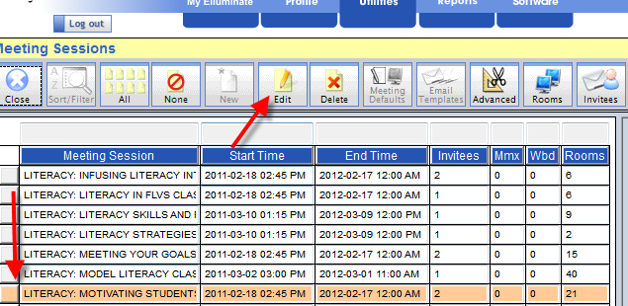

- Check Enable Recording Viewer Details and click Save

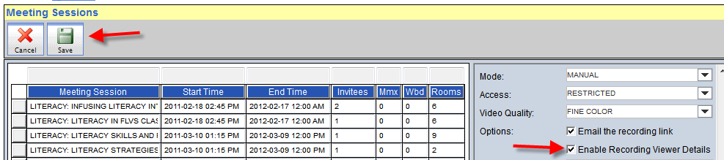

To Use:
- Sign in, go to Utilities
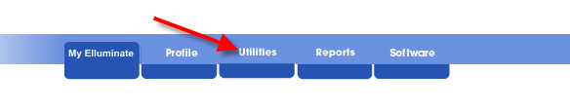
- Click on Files under File Management

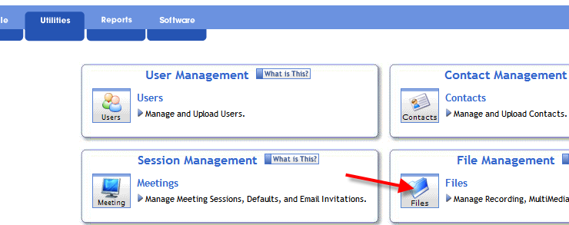

- Click on Recording
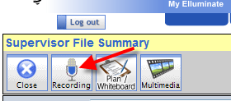

- Click Accept
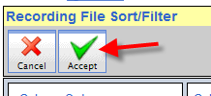

- Highlight the session and click Downloads
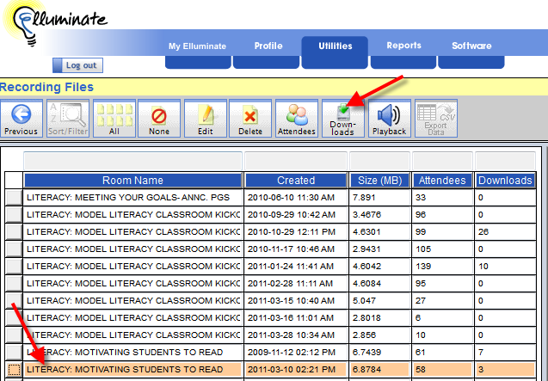

- You can Sort/Filter the information by any of the headings.
